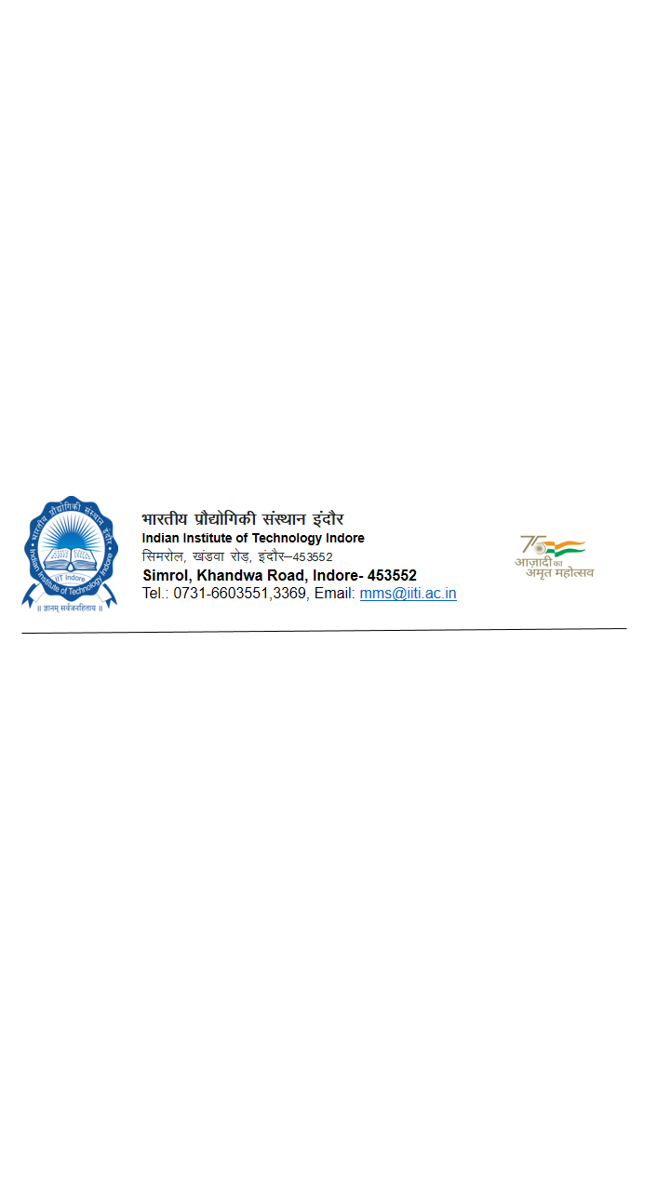

**INSTALLATION / COMMISSIONING / SERVICE REPORT**

**Ref. PO No. _____________________________________________ Date: ______________________**

1. **Name of Equipment: __________________________________________________________________**
2. **Equipment Model No.: ________________________________ MAKE: __________________________**
3. **The above equipment has been successfully Installed/Commissioned/Serviced by __________________ (Name of service engineer) of M/s.______________________________________________ (Address of Supplier/Firm/Dealer) on_____________(Date of Installation)**
4. Contact No.: _____________________ e-mail id: ___________________________________
5. In the presence of Dr./Mr.______________________ of_____________ Department at IIT Indore.
6. ***Date of Visit __________________ Time of visit: _________________***

**_______________________________________________________________________________________**

**STATUS OF WORK:**

**COMPLETE INCOMPLETE REJECTED**

**_______________________________________________________________________________________**

1. The Equipment/Instrument was unpacked, Commissioned / Installed and found to function to the satisfaction level of the User/Buyer.

**(Tick A or B)**

**OR**

1. The Equipment / Instrument was unpacked, Commissioned / Installed but was not working/functioning properly to the satisfaction of the User/Buyer due to the following reasons:

**(Tick A or B)**

(i)

(ii)

(iii)

(iv)

Signature with seal of the Buyer Signature with seal

Name & Designation Name & Designation of the

Service Engineer