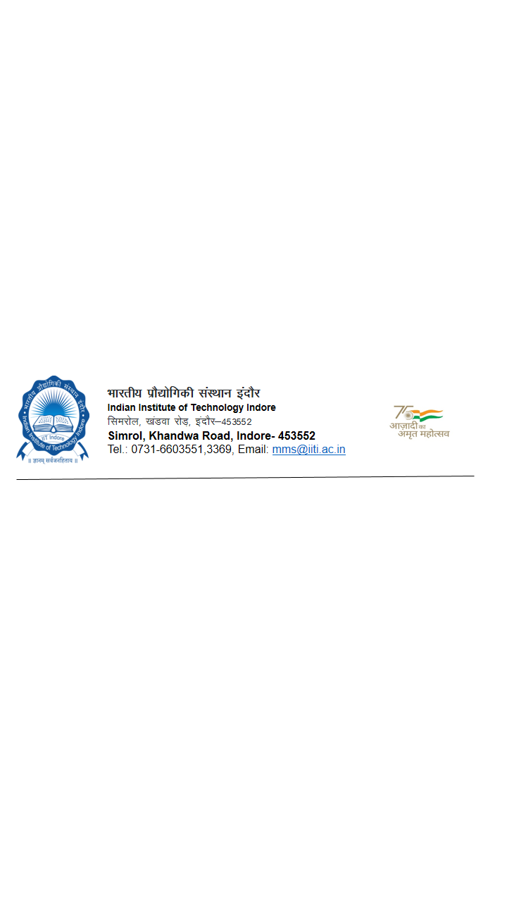
Format for Purchase Indent under GeM
(Direct Purchase through GeM for Rs. 1 to Rs. 25,000/-)

Indent No. ---------------- Date: -----------
Department/Division: _______________________________
Name of Indentor: Designation: _______________________

Indent Approving Authority: ________________________________________________

01. Type of Indent: (a) Equipment/Assets (b) Consumable (c) Services (d) Others
(Tick the Option)

02. Budget Type. (a) Plan (Institute) (b) Non-Plan (c) Departmental
(d) Project funded by:_____________ (e) Other (Specify)-_______________
(Tick the Options

03. Total Estimated Cost in INR (based on budgetary quotes): INR--------------(In Words-_________________
_______________________________________________________________________________________)
04. Specification/s:
Sl. No. | Item | Nomenclature/Description of the item | Quantity | Unit | Estimated Cost | Remarks(Teaching/Research/Other)
05. Purpose of the requirement with complete need justification indicating Teaching/Research/facility/other requirements (separate sheet may be attached)

06. Expected Delivery Terms
a. Delivery Period:
b. Venue (Point of Destination and Installation) :
c. Contact person details like mobile no. & Email etc.
07. Any others requirement such as installation/Commissioning/Warranty/PDI/Training etc. :

08. Login date ________________ time _____________( Login time 09.30AM to 5.30 PM, MON-FRI)
09. Name of representative to finalize the item through GeM on non –availability of user/ Indentor____________
Certified that the Specification of this Indent are Generic and broad based without having any Restrictive Parameters to suit any particular Source of Supply.

Signature of the Indenting Officer with date
(Name & Designation, Contact details)

Signature of the Indent Approving Authority
Name & Designation)

FOR USE BY ACCOUNTS/ R&D
Availability of Fund in the Budget:
Allocated Budget | Total Commitments till date excluding this indent | Available fund for this indent | Balance Available | Remarks

Dealing Assistant FAS / R&D

To
JR-MM

Note :
On finalization of item & acceptance of the same by user the item will be locked/ booked for sanction. The price booked will remain booked for 05 days for initiative approval offline.

