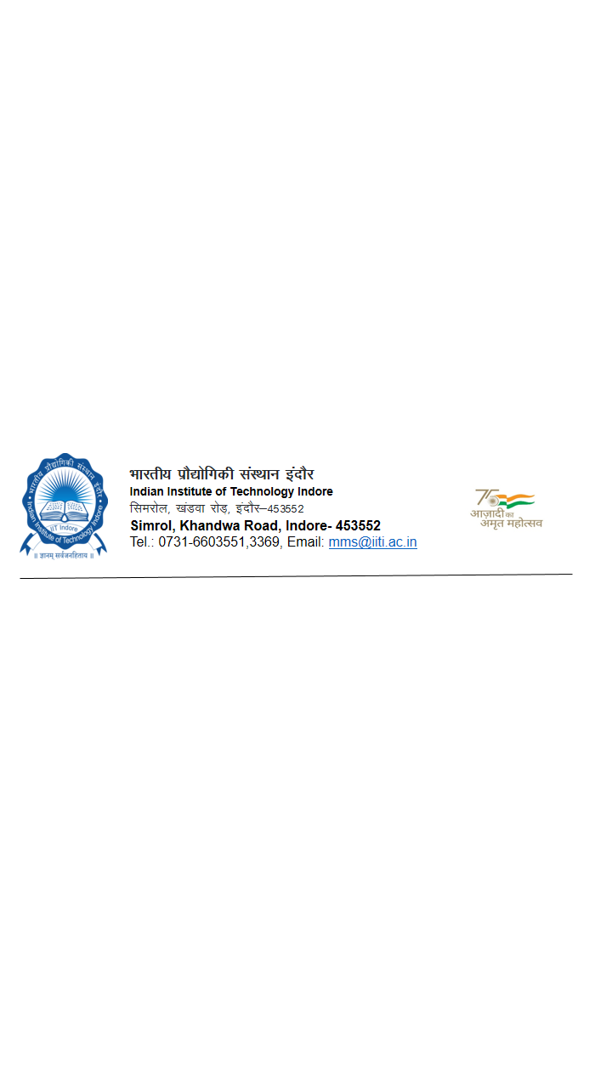

Format for Purchase Indent

Indent No. ---------------- Date: -----------

Department/Division: _______________________________

Name of Indentor: Designation:_________________

Indent Approving Authority:_____________ Designation:_________________

01. Type of Indent: (a) Equipment/Assets (b) Consumable (c) Services (d) Others
(Tick the Option)

02. Budget Type. (a) Plan(Institute) (b) Non-Plan (c) Departmental
(d) Project funded by :_______(e) HEFA (f) Other (Specify)-_______________
(Tick the Options

03. Source: (a) Local/Indigenous (b) Foreign
(Tick the Option)
04. Specification/s:
Sl. No. | Item/Service | Detailed Nomenclature/Description of the item/Scope of Work | Qnty. | Unit | Estimated Cost | Remarks  (Teaching/Research/Other)
05. Purpose of the requirement with complete need justification indicating Teaching/Research/facility/other requirements (separate sheet may be attached)
__________________________________________________________________________

06. Total Estimated Cost in INR(based on budgetary quotes): INR_________________(In Words- ______
___________________________________________________________________________________)
(The estimated price is inclusive of all taxes, overhead charges such as freight, insurance, duty etc.)

07. Nature of the material indented *: (a) Proprietary:
(b) Single Source/Specific Brand/Make:
(c) Others:
* Please attach relevant certificate in standard format/s.

08. Expected Delivery Terms
a. Delivery Period:

b. Venue (Point of Destination/Unloading and Installation) :

c. Specific Delivery requirements such as Unloading/Storage/ Site preparation etc.

09. Any others requirement such as
a) Installation/Commissioning/Training etc.:
b) Warranty
c) Pre-dispatch Inspection
d) AMC charges, if required:
e) Separate sheet may be attached for specific evaluation criteria to be inserted in the NIT/TENDER
f) In case of service- detailed scope of work should be enclosed

10. Declaration:
Availability of Item on GeM (https://gem.gov.in/)__________________________________
(if the indented item is available on GeM, it is mandatory to procure the item through GeM or if is not available, procurement procedure will be as per GFR 2017 & Purchase Manual.
User department should attach the screenshot of the item for further process.

11. List of Suggested Vendors/Suppliers with their Contact details:
Sl. No | Name of the Firm | Contact details | Remark
Certified that the specification of this Indent are generic and broad based without having any Restrictive Parameters to suit any particular Source of Supply. No make and model is specified in the indent.

Signature of the Indenting Officer with date
(Name & Designation, Contact details)
Signature of the Indent Approving Authority
(Name & Designation)

FOR USE BY ACCOUNTS/ R&D
Availability of Fund in the Budget:
Allocated Budget | Total Commitments till date excluding this indent | Available fund for this indent | Balance Available | Remarks

Dealing Assistant FAS / R&D

To
JR-MM

