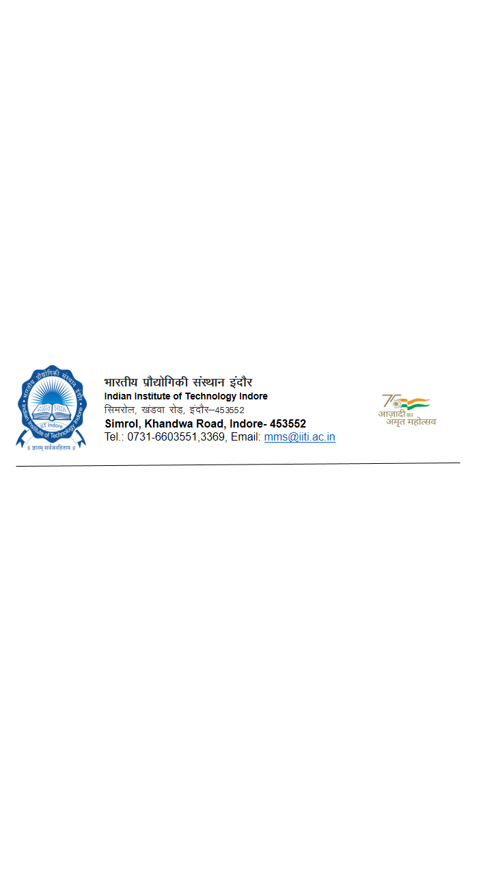

**Requisition Form for GST Certificate**

**(Direct Purchase)**

|  |  |
| --- | --- |
| **Indentor’s Name:** | **Designation:** |
| **Department/center/Unit:** | **Budget Head:** |
| **Email ID:** | **Contact No:** |
| **Purpose of the requirement with detailed need justification:** | |

|  |  |  |  |  |  |  |  |  |
| --- | --- | --- | --- | --- | --- | --- | --- | --- |
| **Sl. No** | **Name of Supplier** | **Item Description** | **Qty.** | **Unit Price** | **Quote No.& date / Performa Invoice No & Date** | **Grand Total** | **CON**  **(√)** | **NON Con**  **(√)** |
|  |  |  |  |  |  |  |  |  |
| **Total Amount** | | | | | | | |  |

**CERTIFICATION BY USER DEPARTMENT:**

1. Certified that the above-mentioned goods/item will be supplied at ____________Dept./Sect./Unit/Center of Indian Institute of Technology Indore, Simrol, Khandwa Road, Indore- 453552 and their application are strictly for our “**Research purpose only”.**
2. **A demand of goods is not divided into small quantities to make piecemeal purchases to avoid the necessity of obtaining the sanction of higher authority required with reference to the estimates value of the total demand.**

_______________________________________

**Signature of Indenter/ Custodian/ Authorized Receiver**

***NOTE:***

***The certificate will be issued in each case certifying that the said good are required for the research purpose only as per GST Notifications. The requisition for the certificate should be submitted well in advance.***